Virtual keyboard:

Initially keyboard:shift.png is already there it is working fine
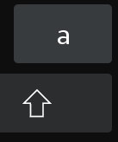
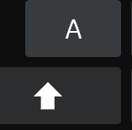
Now I am add new image .intially it is showing but when click capslockleft button updated_icon image was not showing.how to show the icon here
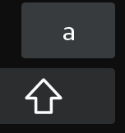
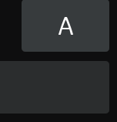

When I click CapsLockLeft button value are not showing

